Running our test
After we have finished working on our tests, we are ready to run them. To do so, we need to do some set-up first:
- Create a configuration file for our cucumber execution
- Install all node dependencies.
- Start up our app web-server (if running web tests)
- Run test.

Configuration files
The first step to run the test, is to create a configuration file. In order to help, there are 3 template files:
- localExample.js: A template file to run web tests.
- localExampleAndroid.js: A template file to run Android tests.
- localExample.IOSjs: A template file to run iOS tests.
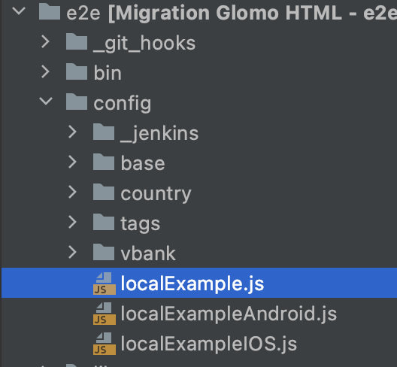
You should create a copy of the needed file and edit that copy (to avoid upload changes on template files). Then you should edit some parts:
- tags: you should specify the tags that you want to execute on your test suite. This relates to the tags we already implemented back when we were defining our features with Gherkin. In the template you will see an explanation of the use of these tags. Check the official documentation for tags expressions: Cucumber API > Tags > Tag expressions.
- specs: By default the test runner will search your tags inside all the files with feature extension inside the lib/epics directory, and this can be slow. To speed up, you can overwrite the array specifying the paths to the files you want to run.
- CHROMEDRIVER_VERSION: The version of chromedriver to communicate with local Chrome. The chromedriver version should match with the Chrome version. Check the chromedriver web to see the list of compatible versions

Node dependencies
Even if you have installed all the dependencies on the main project, you still need to install the dependencies of the suite test. Remember to run the command npm install while on the directory test/e2e inside the project.

Running tests
To run run the test you just need to provide the configuration file, with the command npm run test:e2e, like the line below:

npm run test:e2e -- -c config/testing_config.js
Note the double hyphen before -c.

Note: in order to launch e2e tests using visual studio code follow up this guideline.

Post-test: Report
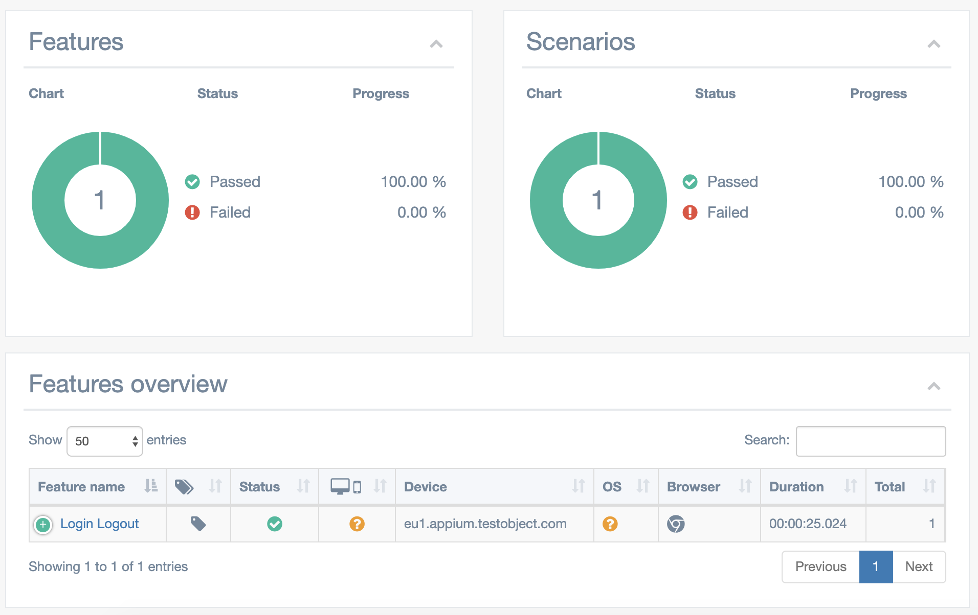
After your test has finished, a report will appear automatically on your browser of choice. This is what it looks like:

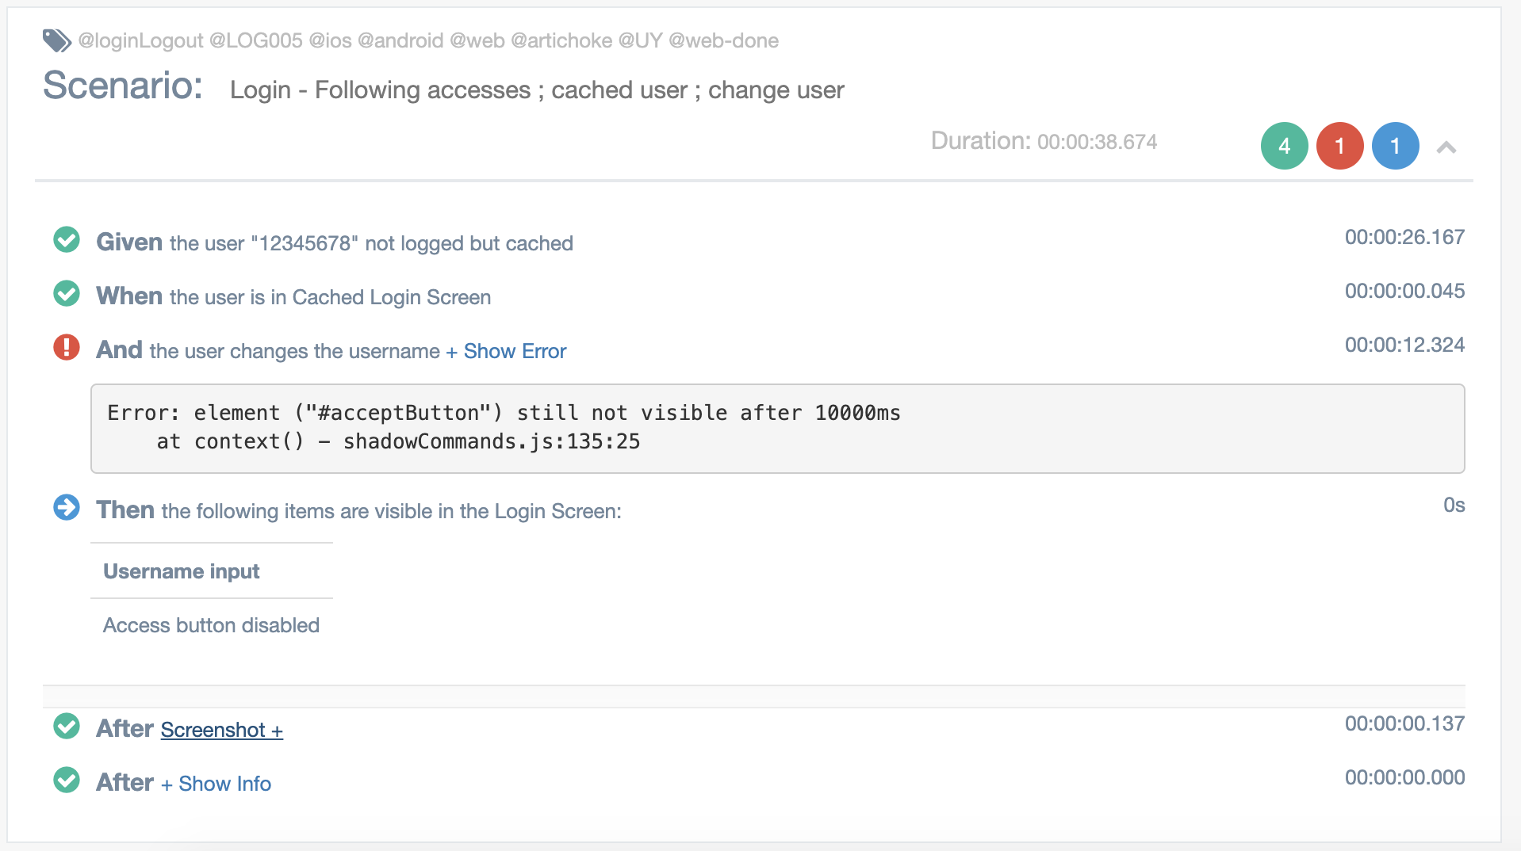
Inside each feature, you will see each execution of a test, and you will be able to see a screenshot and the error report if there were any errors.

